**Homework #4 Report**

Hoaxing Wang

#932359049

**All of the works were implemented in Matlab.**

*Part 1 – Shape descriprion*

The boundary detection is done by the Matlab function “bwboundaries()”. The number of points detected for each image is too huge to handle so they are subsampled to 30 points for each image. The return values are stored into one 1*1400 cell. In the cell are 1400 matrices which contain 30*60 matrices. Each matrix contains the 60-dimensional beam angles for 30 points.

To calculate the beam angles, I used a three-level-nested “for” loop to find every triangle formed by three points on the boundary. For each triangle, the Law of cosines is applied and the angle of each of three corners in the triangle are calculated. After all of the angles are calculated, the histograms are formed in order to get the beam angles.

*Part 2 – Shape matching*

This part is the largest part of the whole homework and it takes the longest time to run. It takes around 4 hours running on my computer. As the result, a 1400*1400 dimension matrix for the total DTW cost *dij* is returned.

To implement this part of the work, I just followed the instructions in the requirement. The two cost matrices C1 and C2 are computed first, and based on these, two accumulated matrices D1 and D2 are constructed. Then the paths result from the DTW matching are also stored in the workspace. The huge runtime comes from the four-level-nested “for” loop in the code, which runs 1400*1400*30*30 times to calculate everything needed.

The *dij* result is so huge that it’s impossible to show in the report.

*Part 3 – Shape retrieval*

This part requires the retrieval error. For each group of objects, one figure will be drawn, so for problem 3.1, 70 images are drawn and they are shown below right after 3.2 problem’s image. In those images, blue stars (*) stand for values for each K, and the red circle (o) stands for the minimum value. As for problem 3.2, only one image will be drawn for the summary of 1400 images. The red stars (*) stand for the values for each K, and the green circle (o) stands for the minimum value.

**The Figure for Problem 3.2:**

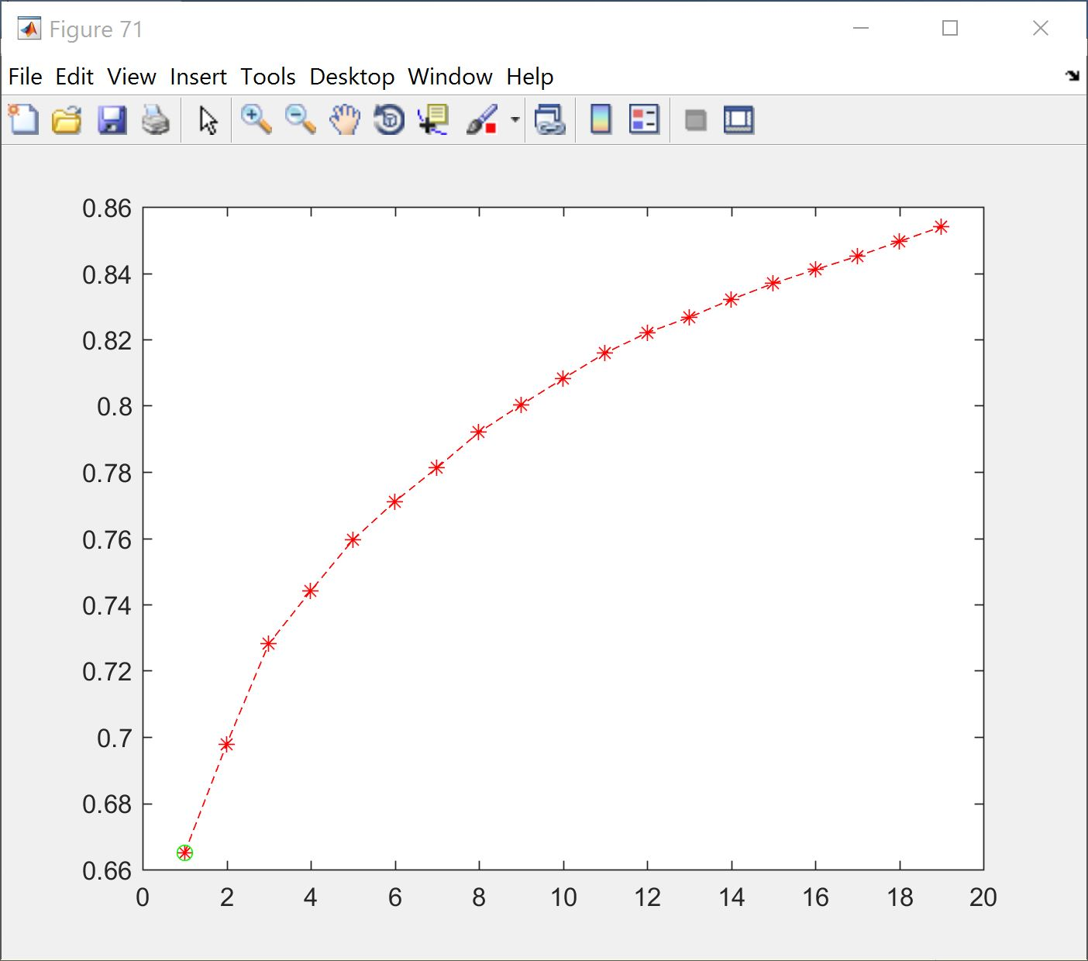

**The Figures for Problem 3.1:**

